Exercise 1: Configuring a Basic Spring Application
Step 1: Create Pom.xml
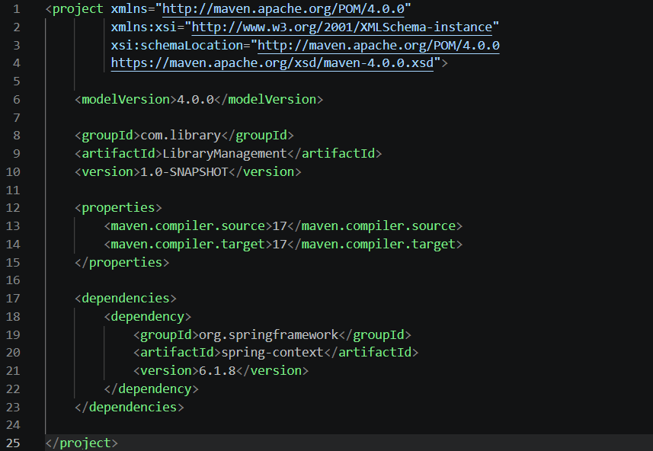
Step 2:Create MainTest.java
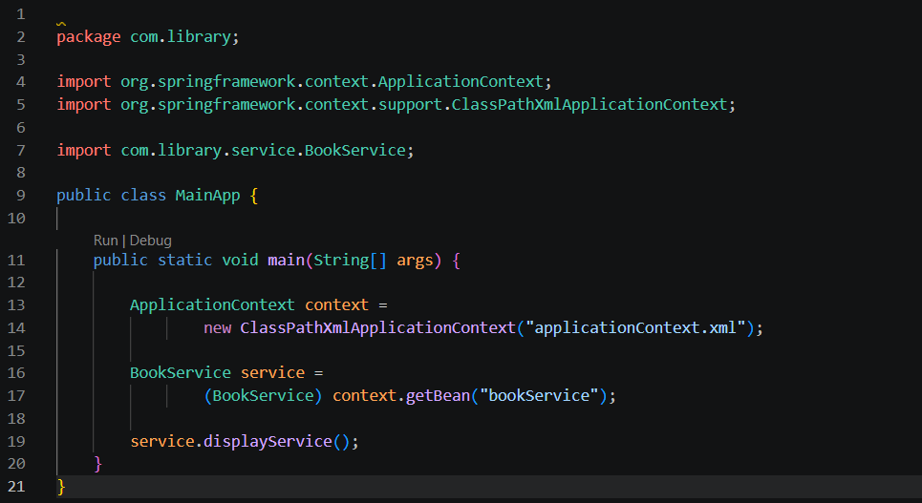
Step 3: Create BookRepository.java
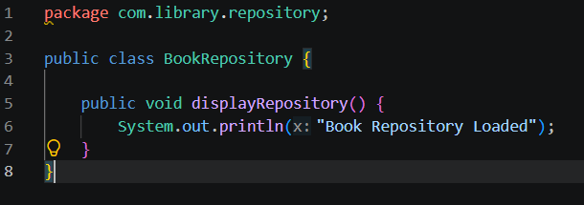
Step 4: Create BookService.java
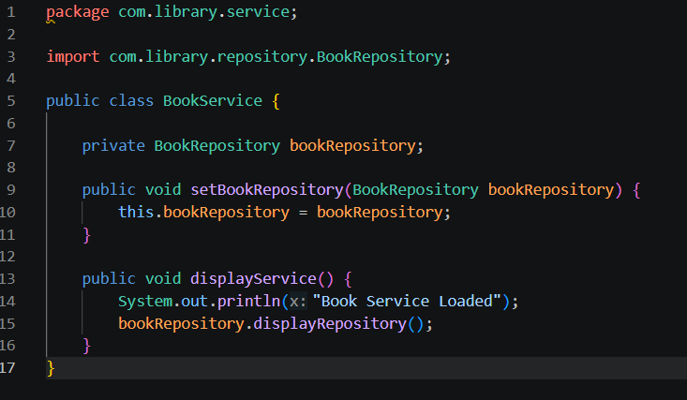
Step 5: applicationContext.xml
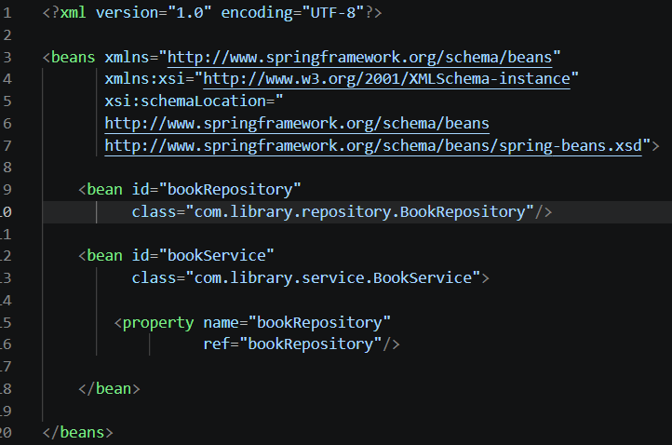
Output:
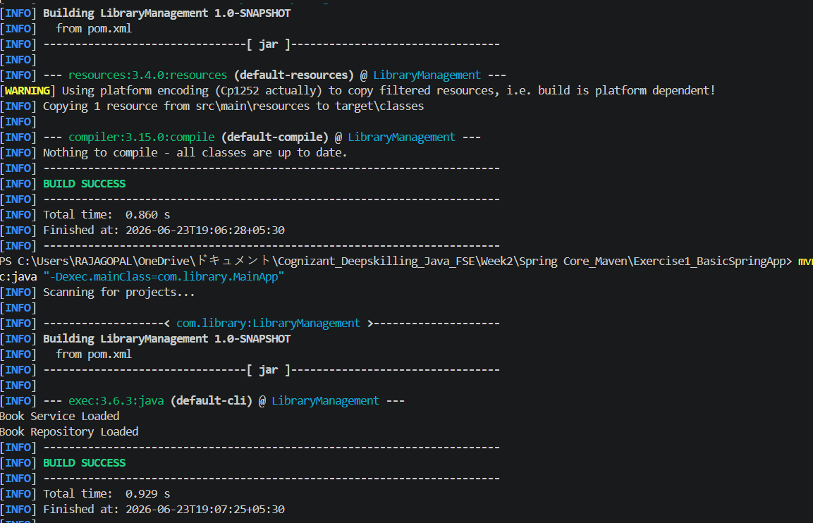

Result:
The basic Spring application was successfully configured using Maven and Spring Core Framework. The application context was loaded successfully, beans were created through XML configuration, and the application executed correctly.

Exercise 2: Implementing Dependency Injection
Step 1: Update applicationContext.xml
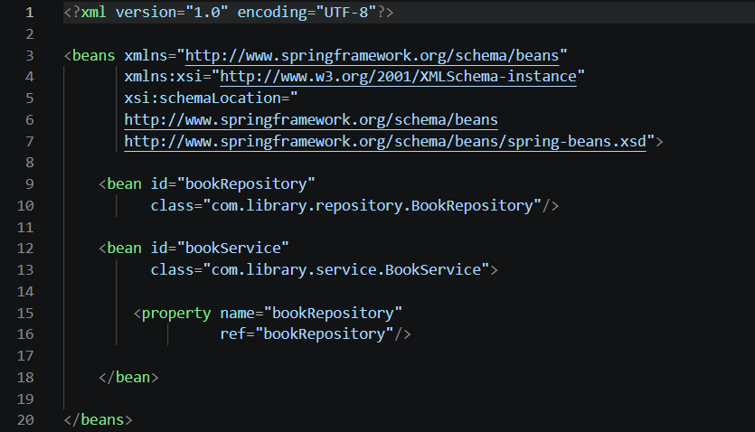
Step 2: Add Setter Injection in BookService
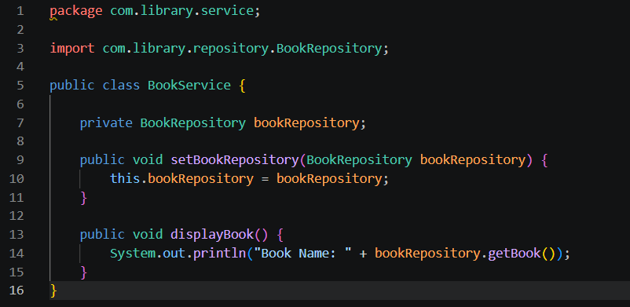

Step 3: Run Application-Output
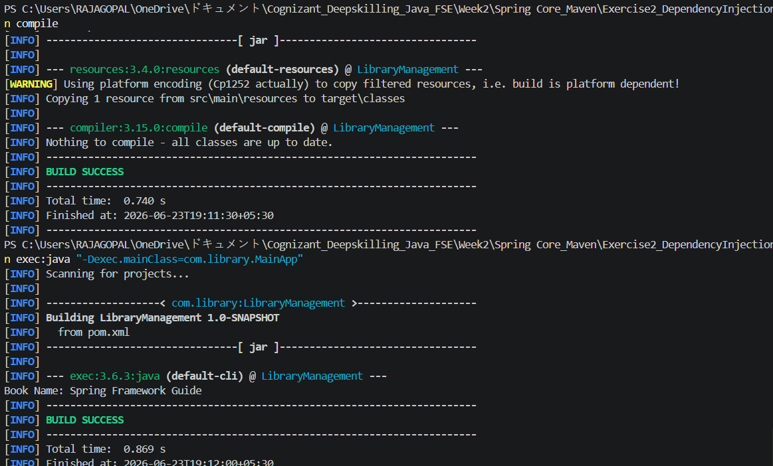
Result:
Dependency Injection was successfully implemented using Spring IoC Container and Setter Injection. The BookRepository bean was injected into the BookService bean and the application executed successfully.

Exercise 4: Creating and Configuring a Maven Project
Step 1:Create MavenDemo.java
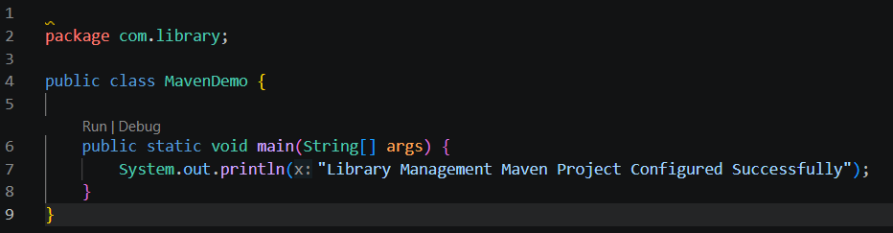
Step 2: Create pom.xml
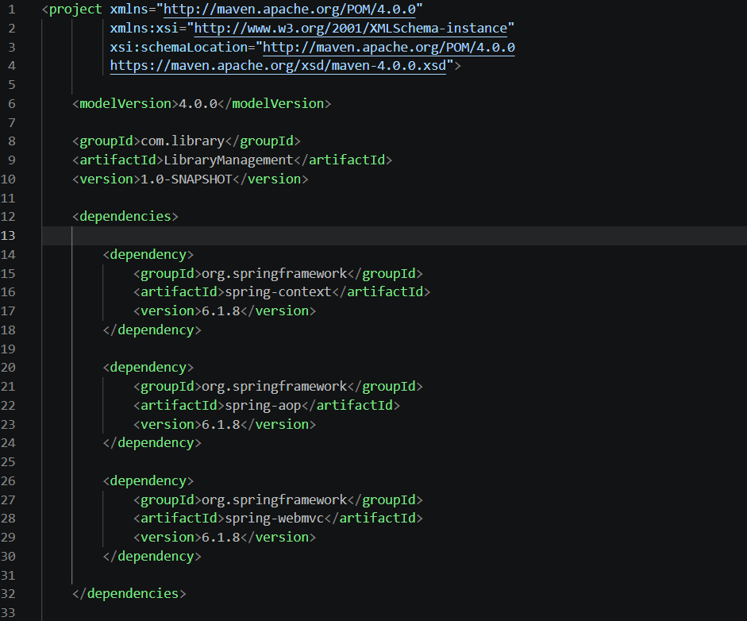
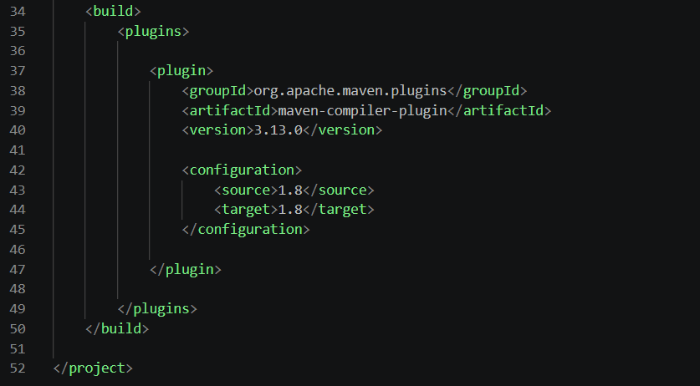
Output:
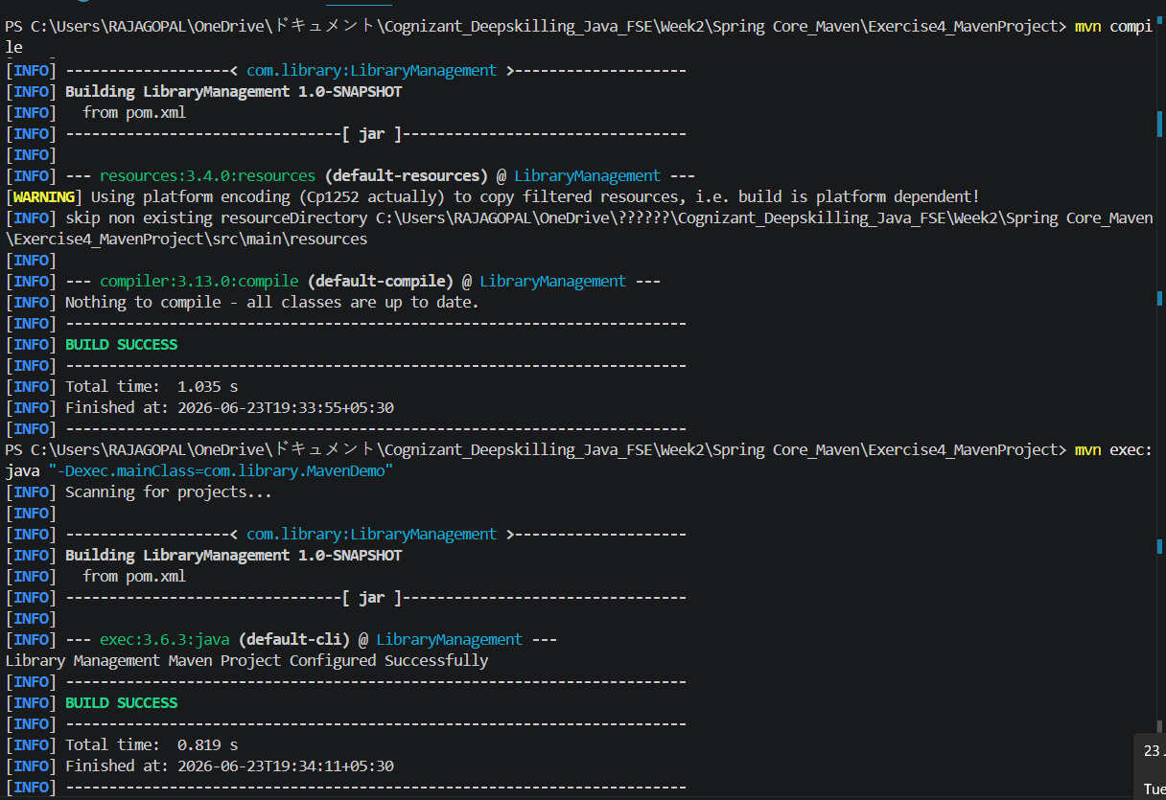
Result:
The Maven project was successfully created and configured with Spring dependencies and Maven Compiler Plugin. The project compiled and executed successfully.

